

|  |  |  |
| --- | --- | --- |
| Course Code and Name: CSE209& Electrical Circuits. | | |
| Experiment no: 7 | | |
| Experiment name:  DC Circuit Analysis in PSpice using Source and Resistance Sweep | | |
| Semester: Fall 2022 |  | |
| Name: D.M. Rafiun -Bin-Masud  Student ID:2019-3-60-137 | Course Instructor information:  M Saddam Hossain Khan.  Senior Lecturer  East West University | |
| Date of Report Submitted:  11-01- 2022 | Pre-Lab Marks: |  |
| Post Lab Marks: |  |
| TOTAL Marks: |  |

**OBJECTIVE**

1.We can verify the DC Circuit Analysis in PSpice using Source and Resistance Sweep

**THEORY AND EXPERIMENTAL METHODS**

The open circuit voltage between the terminals and Rth is the ratio of the open circuit voltage to the short circuit current through the terminals

**Circuit:**

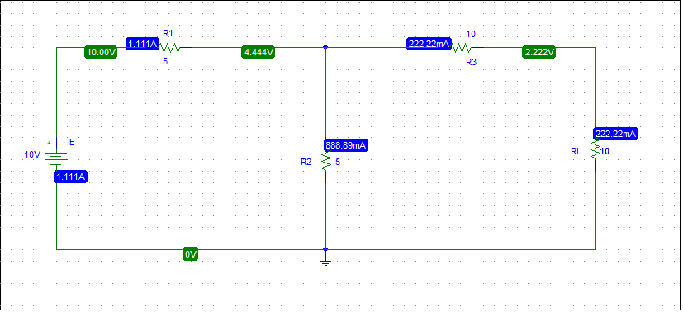

**VOC:**

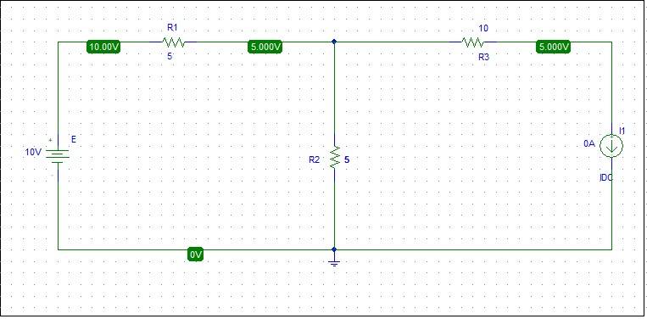

**ISC:**

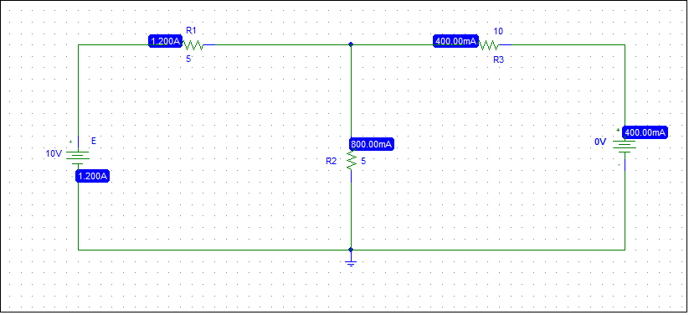

**Rth = Voc/ ISC**

**= 5/400mA**

**= 12.5 ohm**

**Step 4:**

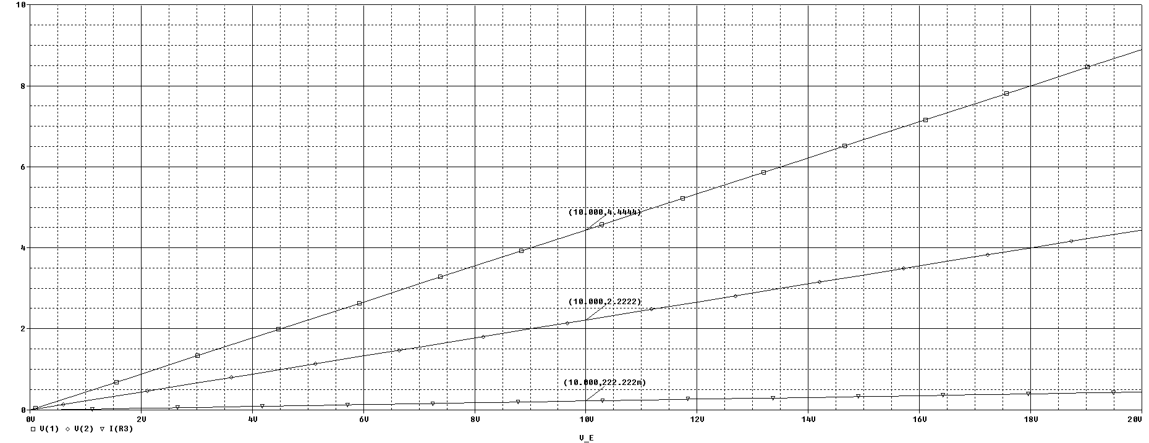

**Step 5:**

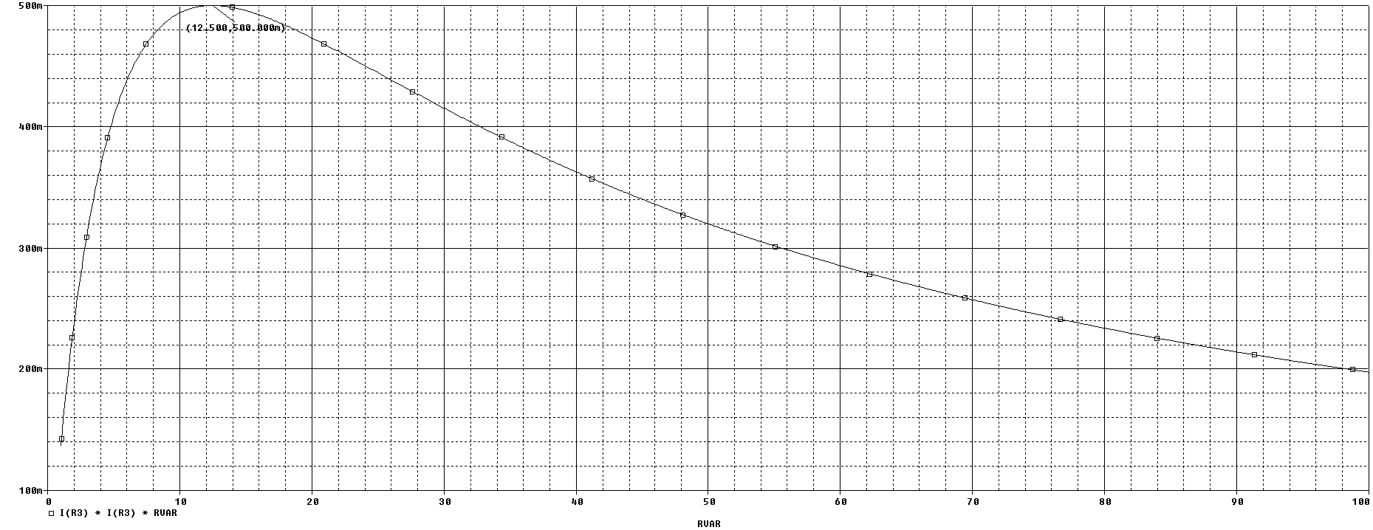

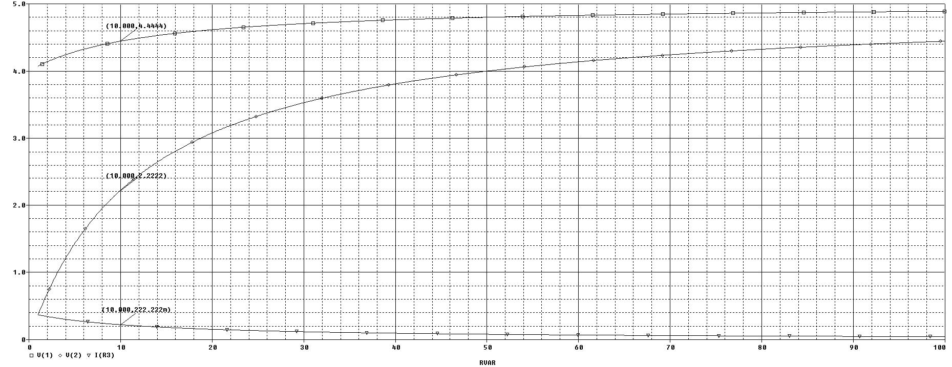

**Post Lab Report Questions:**

**Solution of Question 1:**

From step 4, we get

V 1 = 4.444V

V 2 = 2.222V

IR3 = 222.222A

Again, from step 5(d), we get

V 1 = 4.444V

V 2 = 2.222V

IR 3 =222.222A

**Solution of Question 2:**

1. From step 2, we get, RL = 222.222mA

And from step 5,

RL = 222.222mA.

**Solution of Question 3:**

By comparing the calculated value and

simulated value obtained from

PSpice, we can say that both calculated value and simulated value are

same. So, there is no discrepancy.

**Pre Lab:**

